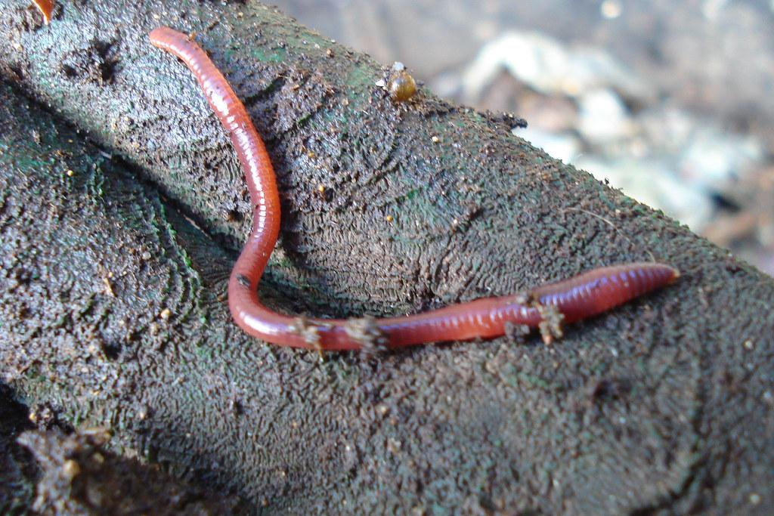

Class Room Vermicompost Bin Program

2021-2022

Overview
TRAD Worm Industries is a commercial vermicomposting company that uses compost worms to responsibly deal with green waste that is produced in our everyday lives. Compostable materials, commonly referred to as organic waste, can be fed to worms to actively reduce landfill debris. A study conducted by the City of Calgary in 2016 determined that, between 65-80% of all garbage that is thrown away is compostable. TRAD proudly acknowledges that children are the future and is committed to interactively educating our future about environmental stewardship. Classroom vermicompost bins provide accessible, educational, and innovative opportunities for Medicine Hat students to collectively participate in environmental sustainability by reducing organic landfill pollution.
Presently, multiple schools within Medicine Hat and the surrounding area are taking part of our in class vermicomposting program, with SD76’s River Heights being our pilot school. The organic waste produced at lunch and snack time was put in the beds. In 2018-2019, the grade 4 classes at River Heights saved approximately 3100 lbs of organic matter from being thrown into the city’s landfill.This translates to removing 1 car from the road for a year. That is amazing!
.

Specifications

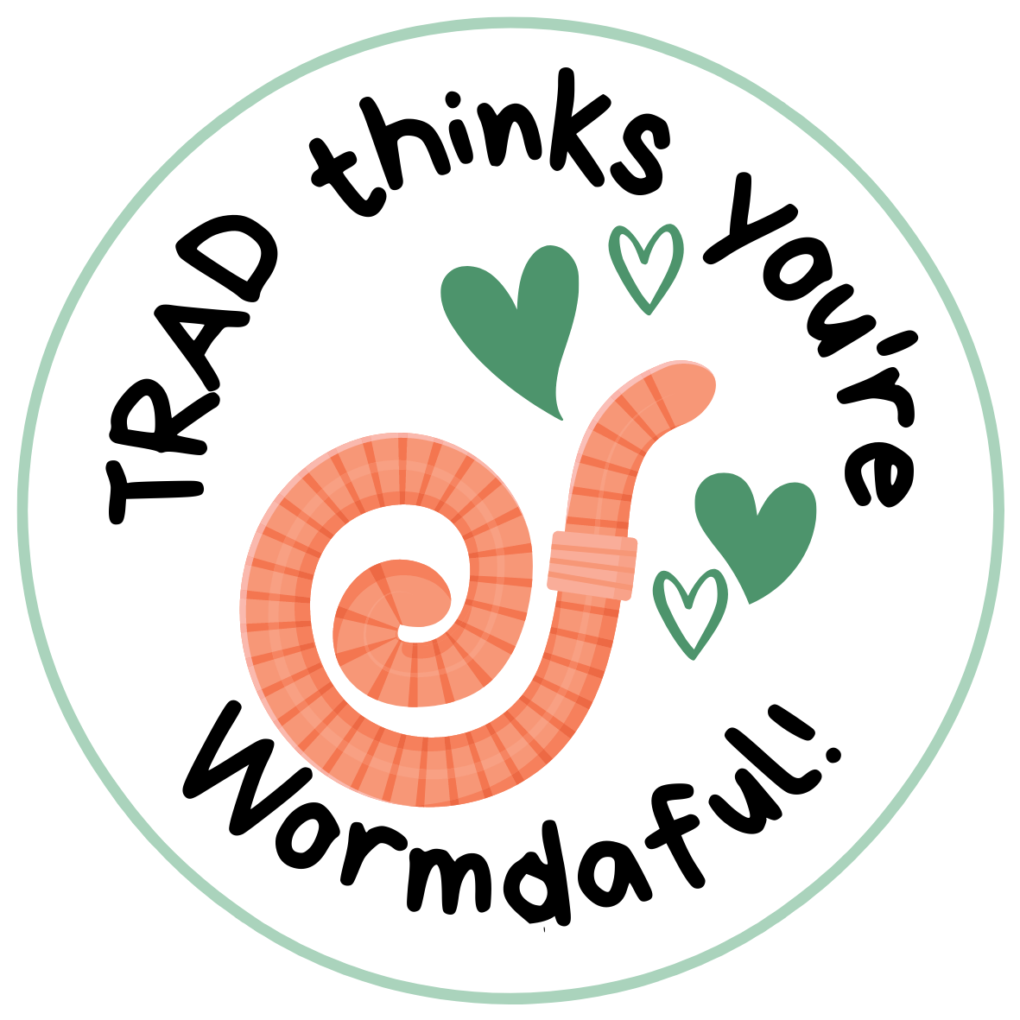
We would like to do a 30 min presentation explaining to the kids why worms are an awesome alternative to the traditional way we are dealing with garbage now. During the presentation, the kids will learn how easy it is to make the change from throwing organic waste into the garbage to feeding the organics to the worms.

Protocols
Worm Beds Set Up & Maintenance
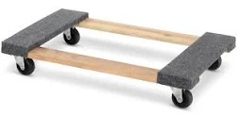
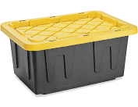
We like to put worm beds in a place that optimally allows for class accessibility. Every two weeks, we trade out the current bed with a fresh bed. Next, we weigh, record, compile the data, and upload the data to your class. Uploading the data provides the ability for you to track the amount of garbage that has been used as feedstock for the worms. The worm bin’s footprint is approximately 2’x2.5’ and can weigh approximately 10 - 15 kgs.

We provide a rolling cart so that the bin can be moved easily around the room.We try to pick up consistently at the same time bui weekly but usually it is Tuesday mornings between 10 -11 am. There is no set time line commitment for your class room's worm bin after the 1 st month. All we ask is that you give us 2 weeks notice if you want to no longer have the bin in your room. If you choose to have a bin in your classroom and participate in our vermicompost program, a detailed agenda of scheduled pickups and the link to access your worm bin information will be provided.
Troubleshooting
We get asked many questions, but the most common are … Does it smell? The answer generally is no; however, there are always exceptions. Are bugs a common issue, like fruit flies? Generally, no, but again there are exceptions.
Just like any living thing, a little maintenance is to be expected. An estimated time allowance for daily maintenance is approximately 10 minutes after they are fed. Ultimately, daily maintenance is a fun hands-on opportunity for you and the children to continuously learn while enjoying active engagement with the worm bin together.
Money
There is a cost associated with our vermicomposting program for continuous maintenance. Vermicompost maintenance ensures optimal experience and continuous learning from our experts for you, the children, and the worms. Worm bed maintenance entails pick up, data collection, access to continuous updated records, and a detailed year-end report. The cost is $50/month and covers a single worm bed, if additional beds are needed to recover all the produced organics they are an additional$25/month. During holidays the bed will be picked up and maintained until the class room reopens for no additional charge.

Thank you
Thank you for considering an environmental partnership with T.R.A.D. Worm Industries. If you have any questions, or would like any additional information please contact us by email: roxanne@tradwormindustries.org.
We are excited about having you join our vermicomposting program and together effectively diverting the organic waste within your center.

Have a Wormdaful day!
Roxanne Doeksen
Founder
T.R.A.D. Worm Industries Ltd.

Roxanne@tradwormindustries.org

(403) 528 0058

